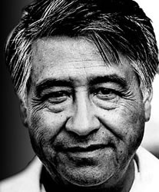
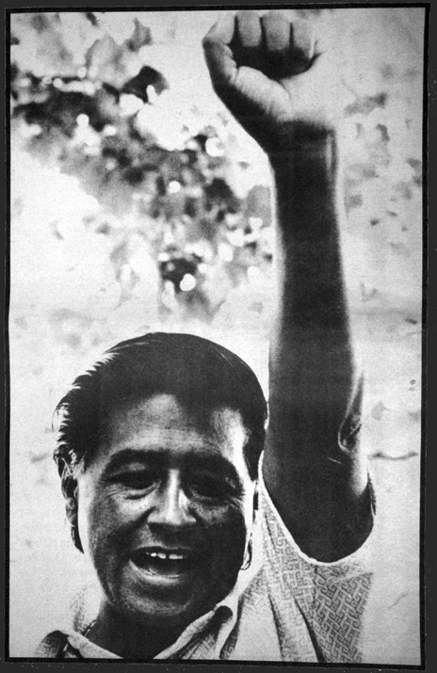
Thank you for participating in our fifth annual Cesar E. Chavez Inspirational Youth Conference, sponsored by the Cesar E. Chavez Commemorative Committee of San Fernando Valley. Please fill out the information below and return form to your Advisor.
8th Annual Cesar E. Chavez
Inspirational Youth Conference
Saturday, March 10, 2017 8:00 am-2:00 pm
Student Registration Form

The Cesar E. Chavez Commemorative Committee
of San Fernando Valley

Student/Participant’s Name:_________________________________________
Grade: ___________ Age: ___________
Home Address:___________________________________________________ City:_____________________State:______________Zip:___________
Home Phone:__________________ Other Phone:________________________
Student/Participants E-Mail:_________________________________________
Parent/Guardian Name:_______________________________
Emergency Phone:___________________________________

School/Organization:_____________________________________
Advisor’s Name_________________________________________

Vegetarian meal needed? Yes No
(due to catering restrictions, vegan and gluten free meals are not available)

Cesar E. Chavez Inspirational Youth Conference Contract
As a participant of the Cesar E. Chavez Inspirational Youth Conference, sponsored by the Cesar E. Chavez Commemorative Committee of San Fernando Valley on March 10, 2018 at the Vaughn International Studies Academy campus, I agree to fully participate in the Cesar E. Chavez Inspirational Youth Conference Event, and will interact with all participants in the spirit of Cesar E. Chavez’s legacy. I will remain with the program at all times, and will not leave the conference without the express permission of my Cesar E. Chavez Inspirational Youth Conference Advisor and making sure that Cesar E. Chavez Inspirational Youth Conference staff are aware that I am leaving the event. I agree to silence my cell phone throughout the event. The Youth Conference will be at Vaughn International Studies Academy 11505 Herrick Ave Pacoima, CA 91331.

WHAT I’LL BRING: Weather appropriate clothing, pens, pencils & notebooks.
WHAT I WILL NOT BRING: MP3 players of any kind, glass containers, weapons, non-prescription drugs, alcohol.

PARTICIPANT’S SIGNATURE: ________________________________________ DATE:___________________ PARENT/GUARDIAN SIGNATURE: ___________________________________ DATE:___________________

ADVISORS/ TEACHERS: PLEASE RETURN ALL COMPLETED FORMS TO: DELARA@PYS.ORG
Do you have any questions? Please call (818) 837-2272

Cesar E. Chavez Commemorative Committee of San Fernando Valley

